

Filling out a 2025 Pack Delivery Form

Support document for Coordinators
You will have noticed that the Pack Delivery form for 2025 looks a little different.
Changes were made following:
- Feedback from Coordinators about how they use the pack delivery form and what information they find useful to collect
- Identification of some gaps in pack delivery data collection particularly around how sites are delivering HIPPY flexibly to families with diverse learning and support needs
- Identifying the need for more opportunities to provide the narrative (or story) behind pack delivery data

Introducing the Pack delivery form 2025
The 2025 Pack delivery form now includes five sections which are explored below

Section 1: General information
This section includes standard information including
- Child’s name
- Tutor’s name
- Date of delivery
- Whether delivery is for Age 3 or Age 4
- Time spent on delivery
All sections apart from the time spent on delivery can be filled out before the visit

Section 2: Review of Last pack
The Review of Last Pack section has two parts
Part 1 records which activities the parent-carer and child did from the previous pack. This information captures family participation in HIPPY
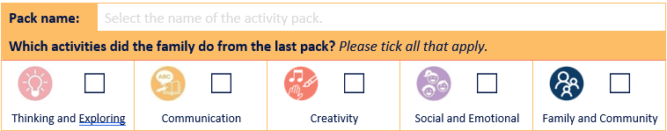
Part 2 records Family Reflections about how the parent-carer and child experienced doing the activities from the previous pack together. This information captures family engagement and enjoyment of HIPPY
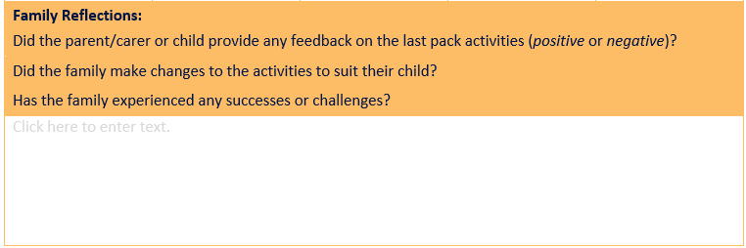
The Family Reflections narrative box replaces the quantitative feedback that was previously being collected from parent/carers and their child.
Examples of Family Reflection comments
Examples of things a tutor might write in the Family Reflections narrative box include
- family wedding last week so it was difficult to find time to do HIPPY so did some Everywhere Learning instead
- Everyone was sick this week, but Mum said they will do the activities over the holidays
- Mum and HIPPY child loved all the activities and particularly Follow the leaders as it was outside
- Dad said HIPPY Child didn’t want to do any of the activities this week
- HIPPY Child really enjoyed the new book and has wanted to read it every day
- Mum said that the activities in Echidna 3 were still too easy and maybe HIPPY isn’t right for them
Tips for collecting feedback for Section 2
- At Age 3 and Age 4 Tutor training practice looking through a physical copy of the last pack with the parent –carer and discussing each activity
- At the home visit Tutors ask the family to find the pack that is being reviewed. Tutors bring a spare pack to the visit in case the family can’t find their copy
- Develop open-ended questions tutors can ask as they briefly discuss each activity such as
  - Did you and/or your child like or not like this activity?
  - Why did you and/or your child like or not like about the activity?
  - What did you do / could you have done to make the activity more enjoyable?
  - What did you learn about your child? What did you learn from this pack?

Section 3: New Pack delivery
This section has two parts. The first part records information about delivery of the new pack including
- Pack delivered
- Number of Activities role played
- Which of the 3Cs, Behaviour specific praise and Everywhere learning were discussed with the family
- Whether the pack was delivered in language and the language the pack was delivered in
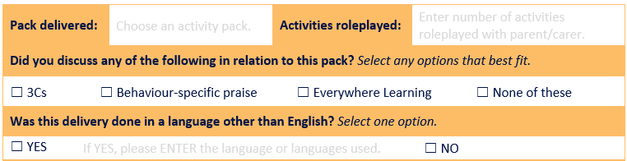
The second part is a new Adjustments narrative box where tutors will record how tutors are customising delivery / offering flexible solutions to make delivery more effective and support family engagement
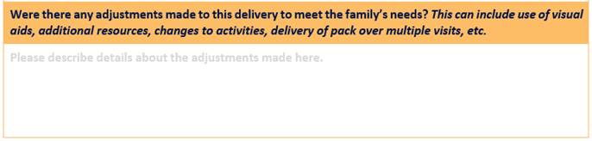
Examples of Adjustment narrative box comments
The Adjustment narrative box may include things like
Family feedback about the activities in the new pack
- Mum said they were a little worried about whether the HIPPY Child would like the activities this week as they were a bit passive, and we discussed how to make activities more active
- Discussed strategies to adapt the activities to outdoors as HIPPY Child likes learning outside
- Modelled picture reading rather than reading all the words in the story to support the child to listen to the story
Use of Visual aids
- Using a video of the song in the activity pack and/or in family’s first language
- Translated materials
- Using pictures to help families understand the activities in the pack
Additional resources used for delivery
- Interpreter for families who speak a language other than English
Delivery adjustments
- Delivering the pack over two visits
- Pack delivery happening at the parent-carers workplace during the lunch break
- Double delivery because family will be away the following week

Section 4: General comments
The purpose of the General comments narrative box is to record general information including reminders, any follow up required for the next visit, family engagement with other services and any change in family circumstances that may have an impact on delivery to families
Examples of what could be recorded in the General comments narrative box
Reminders
- Reminded Jen about guest speaker at gathering next week
- Gave out the Children’s Week event flyer
Follow up
- Will discuss financial support services with Coordinator and share with family at next visit
- Said I would bring information pack about local school next week
Referrals and other services
- Have families start engaging with any local services?
- Family going on holiday
- New baby and family planning a break from HIPPY
- Starting/ change to work
- Health related

Section 5: Referral to a service
This section is the same as on the 2024 Pack Delivery form and records information about whether a family were referred to a service as part of this delivery and the service(s) they were referred to.

